**THE MAHARAJA SAYAJIRAO UNIVERSITY OF BARODA**

## FACULTY OF TECHNOLOGY AND ENGINEERING



## A PROJECT REPORT

### on

Ludo Game

***In fulfillment for the course of* Java Programming (MCA1202)**

#### *Of*

## MASTER OF COMPUTER APPLICATIONS

### in

### The Department of Computer Science and Engineering

|  |  |
| --- | --- |
| **Name** | **PRN** |
| Brijesh Paghdal | 8021045601 |
| Mukhtar Wafa | 8021080104 |
| Chirag Valmiki | 8021077862 |

# Abstract

This document is intended to report Java mini project by students of Master of Computer Applications – i.e., ours. This report discusses our experience as a software developer in a project from May 2022 to June 2022.

Ludo Game is a computer program that imitates the manual method of playing ludo board game. The motivation behind this project work is the need to strengthen students understanding of processes and digital literacy and more specifically their reflective understanding of video games. We have created this game with the help of Core JAVA, awt(Abstract Window Toolkit) and Swing.

# Table of Contents

Abstract 2

Table of Contents 3

Preface 4

Acknowledgment 5

About Project 6

Tools, Technologies, Libraries & Features 7

FlowChart Diagrams 8

Test Cases 9

Screenshots & Explanation 10

User Manual 12

References and Bibliography 15

Conclusion 16

# Preface

After studying Java for a semester in SSMCA, we got to imply our knowledge of coding / programming, teamwork, communication skills, tools, strategies, and creativity into this project.

This project is for a subject of second semester of Master of Computer Applications whose subject code is ‘MCA1202’. It must be completed by group of three students. “Ludo game” is the project of our group, which includes 3 members (us): Brijesh Paghdal, Mukhtar Wafa, Chirag Valmiki.

This game imitates the manual method of playing ludo board game. 4 player can play the game at a time The motivation behind this project work is to get better understanding about core java and awt to make better desktop applications.

As the term of semester 2 is coming to an end, we are submitting this document to our course teacher Ms. Mamta Padole, which includes diagrams, strategies, features and limitations of an application.

In this document, we tried to make everything i.e., sections and diagrams with explanations, consistent, subsequent, and easy to interpret by anyone who knows at least basics of software engineering.

As this document will not be read by only faculties but also by junior students of our succeeding batch to document their project like this. With this concern in mind, we are putting strategies and methods along with appropriate graphics, which we have considered while working.

# Acknowledgment

Foremost, we would like to express our sincere gratitude…

To Dean of the Faculty of Technology and Engineering, Prof. (Dr.) Chivukula N. Murthy and our Head of the Department, Prof. (Dr.) Apurva M. Shah for providing us an opportunity to show our knowledge which we gained here; And for sharing their personal experiences about system and software development on-field, too.

To our subject teacher, Ms. Mamta Padole for advising us throughout the project with her personal experience and professional ideas, who did not only recognize our mistakes but helped to solve them. We feel blessed because of her.

###### What is a Ludo Game?

# About Project

Everyone must have once played a ludo game in their life. This is a board game. In this, there is a maximum of 4 players. Every player has 4 tokens. Players have to race their tokens and tokens have to reach the home again.

**What are the rules of this Game?**

* Every token is initially locked in the home. The player has to roll a dice and if one appears on the dice then the user can unlock one token
* Every token has to start from home and take a round trip to reach its final state.
* Each time player has to roll a dice and whatever number appears on the dice, the player has to move his token by that many steps. It’s his choice which token he wants to move.
* If number 6 appears on the dice, then the player will get to roll the dice again.
* If 3 6s appear in a row, then the turn is forwarded to the next player.

**Features of Ludo Game**

* This is a single-screen application.
* This is an offline application.
* It is a multiplayer game.
* Maximum 4 players offline can play this game
* Very simple GUI

# Tools, Technologies, Libraries & Features

* IDE (Integrated Development Environment)
  + **Eclipse IDE for java development** : It includes a text editor, a compiler, and a display window. It enables the creation of software within a carefully designed set of constraints.
* Technologies
  + **Awt** : Abstract Window Toolkit (AWT) is a set of application program interfaces ( API s) used by Java programmers to create graphical user interface ( GUI ) objects, such as buttons, scroll bars, and windows. AWT is part of the Java Foundation Classes ( JFC ) from Sun Microsystems, the company that originated Java.
  + **Swing** :Swing is a Java Foundation Classes JFC] library and an extension of the Abstract Window Toolkit [AWT]. Swing offers much-improved functionality over AWT, new components, expanded components features, excellent event handling with drag and drop support.
* Features of Java we employed within our project are as follows:
  + **Swing**: Java Swing is a lightweight Java graphical user interface (GUI) widget toolkit that includes a rich set of widgets.
  + **OOPs**: It is about creating objects that contain both data and methods. It is a paradigm

**Flow Chart Diagram**

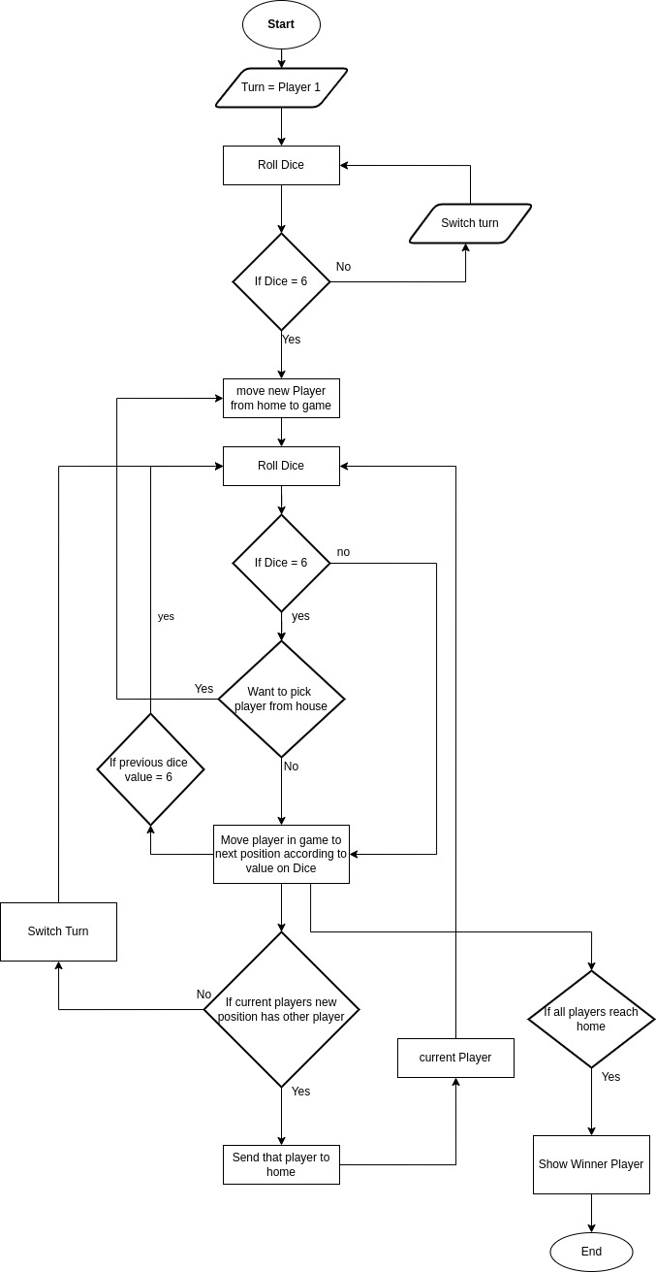

# Test Cases

*“Discovering the unexpected is more important than confirming the known”*

*– George E. P. Box*

“Test cases” in our project can also be called “User scenarios” as we are not considering every kind of test.

|  |  |  |
| --- | --- | --- |
|  | Action | Output |
| Scene – 1 | Click on Dice button | Starts the game |
| Scene – 2 | If dice gets 6 value | move the player from home to path |
| Scene – 3 | Click on dice button | Move the player to given steps according to dice number |
| Scene – 4 | Change the turn | So the player 1 turn will be over now it’s player 2 turn and so on... |
| Scene – 5 | Player reaches to other player | If two player crashes together then the idle player will have to start again from home |
| Scene – 6 | Player reaches to other player in safe zone | If two players meet at the safe zone then don’t take any action |
| Scene – 7 | Player kills other player | The player that killed the other player gets extra move |
| Scene – 8 | Check if all player character reach to home | Show the winning sign. |

# Screenshots & Explanation

**How to play the game?**

When we first run the application we will see the screen given below.

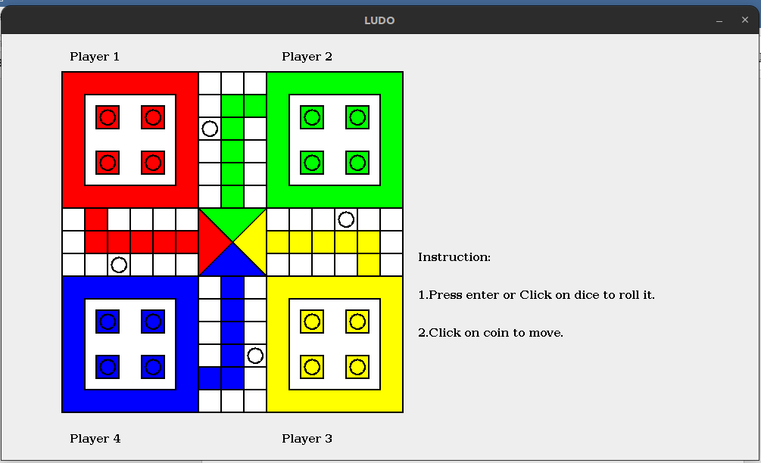

Press enter to start the game .

After pressing enter it’s player 1 turn :

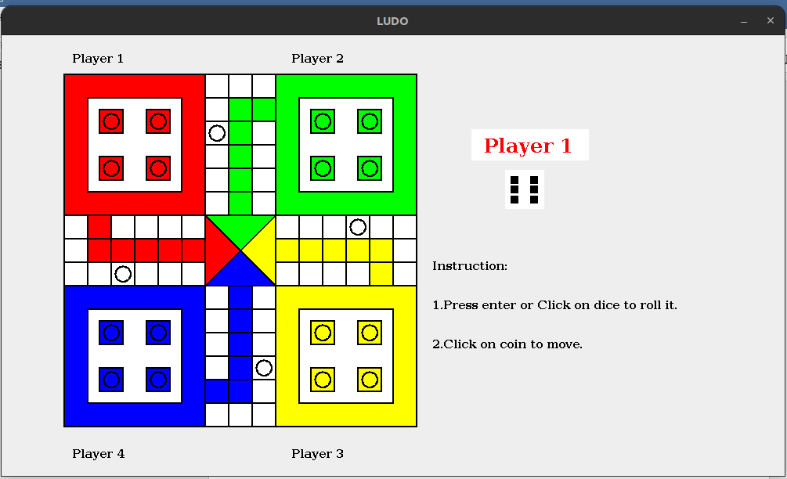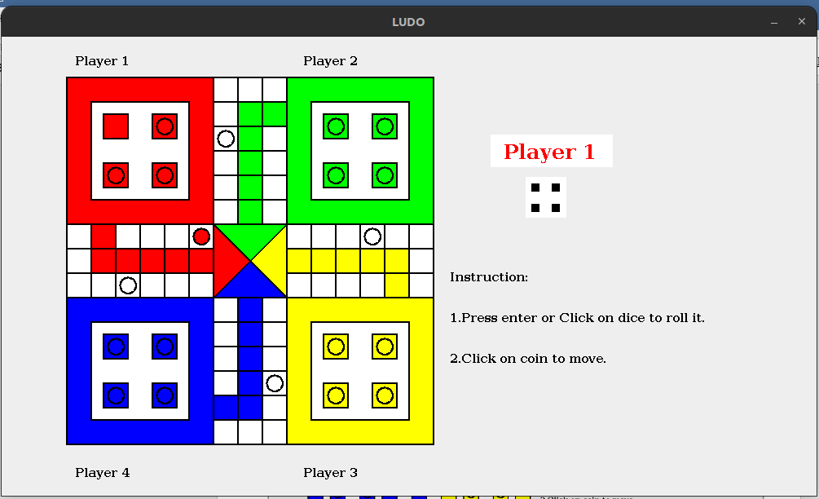

Now press enter to click on the dice given on then screen .

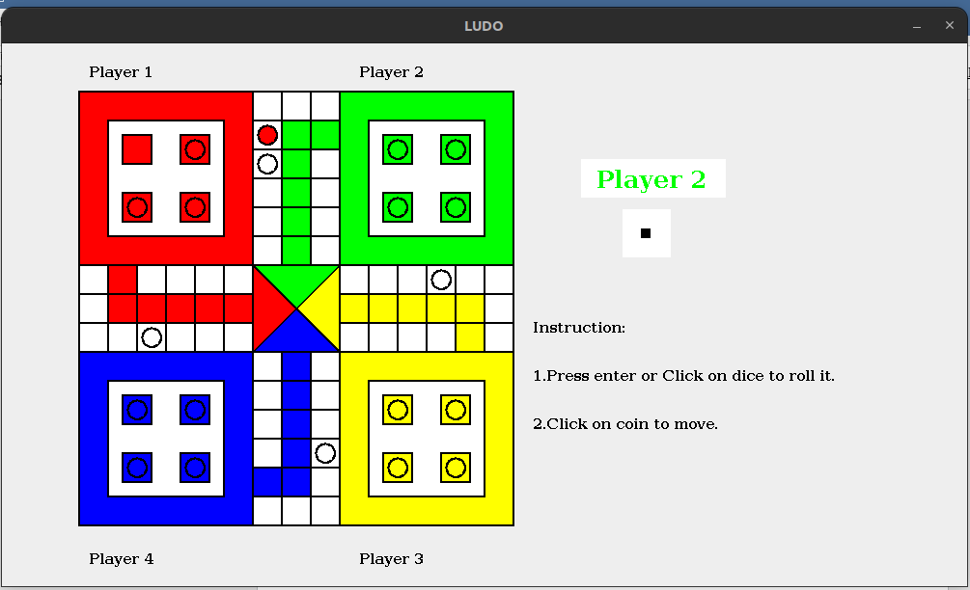

Now like this we can play the game.

**User Manual**

**How to execute the application?**

There are two ways to execute the application.

**1.Using command prompt :**

step 1. goto command prompt and type the following code .

java -jar "file_name.jar"

ex : java -jar "Ludo.jar"



**2.Using user interface :**

if you are using linux operating system do as following

step 1 : right click on "Ludo.jar" file

step 2 : click on properties

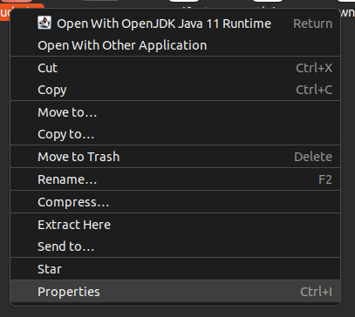

step 3 : Click on 'Permissions'.

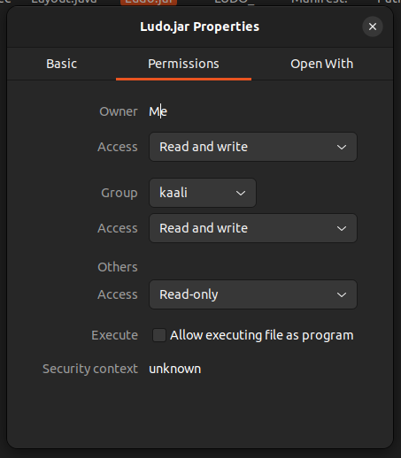

step 4 : check the box that says "Allow executing file as program"

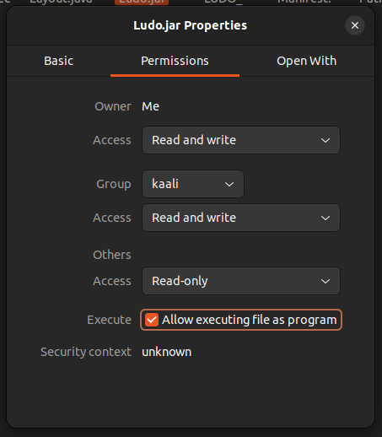

step 5 : click on 'open with' and select openjdk java 11 runtime as default app to run the application

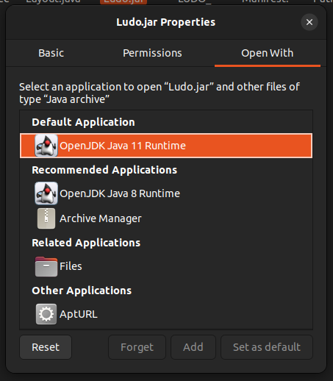

step 6 : close the 'properties' box and double click to play the game.

# References and Bibliography

1. <https://docs.oracle.com/en/java/>
2. <https://www.javatpoint.com/java-awt>
3. <https://creately.com/diagram/example/htfxacl02/ludo-game>
4. <https://www.javatpoint.com/java-swing>

# Conclusion

This project boosted our knowledge and skills required in a corporate world specifically. Also, it exposed us to new technologies like processing and its whole environment of libraries and allowed us to improve on our previous knowledge of JAVA. We learnt teamwork, planning and human resource management.

In our team, there was a vast difference between the knowledge of the members, so, it was hard to keep everyone on the same page, but we learnt to overcome those limitations and finally achieved our goal.

